KENOSHA COUNTY

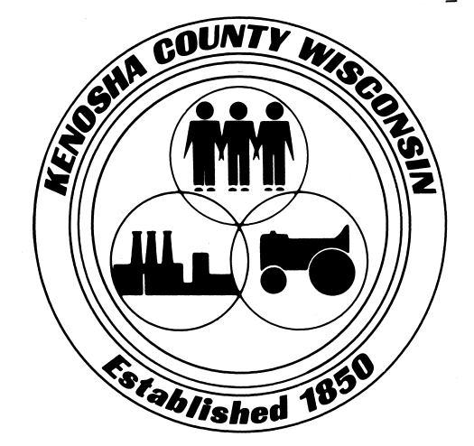

**BOARD OF SUPERVISORS**

**Resolution No. ________**

|  |  |
| --- | --- |
| Subject:  **A Resolution Recognizing May 2024**  **as “National Foster Care Month”** | |
| Original [ x ] Revised [ ] 2nd Correction [ ] Resubmitted [ ] | |
| Date Submitted: 2/27/2024 | Date Resubmitted: |
| Submitted by: Vice Chair Decker, Supervisors Rodriguez, and Poole | |
| Fiscal Note Attached [ ] | Legal Note Attached [ ] Agreement |
| Prepared by: Vice Chair Decker | Signature: |

WHEREAS, Kenosha County’s children and youth are our hope for the future, and we assert that all children deserve a safe, loving, stable, and nurturing family; and

WHEREAS, families, serving as the primary providers of love, identity, self-esteem, and support, are the very foundations of our county; and

WHEREAS, kinship families and foster families play a critical role in serving as a support, not a substitute, for the parents of children in foster care to make family reunification possible; and

WHEREAS, supporting foster care children, their foster families, biological families, and services that support foster children can change generations, break cycles of abuse, prevent exploitation, and give children the opportunity to thrive; and

WHEREAS, many kinship families and foster families create permanency for children in foster care through adoption when those children cannot be safely reunified with their birth families; and

WHEREAS, children available for adoption are currently receiving foster care services; most of the children waiting to be adopted are school-age children, teenagers, groups of siblings who want to stay together, children with special needs, and children of color; and

WHEREAS, it is vital that Kenosha County ensures that all qualified individuals have the support, resources, education, and opportunity to serve our most vulnerable population as foster, adoptive, or kinship parents; and

WHEREAS, Congress passed Senate Joint Resolution 59 and on May 10, 1988, President Ronald Reagan proclaimed May as “National Foster Care Month” under Proclamation 5820;

NOW THEREFORE BE IT RESOLVED, that the Kenosha County Board of Supervisors does recognize May 2024, as National Foster Care Month in Kenosha County; and

BE IT FURTHER RESOLVED that the Kenosha County Board of Supervisors recognizes and thanks the many foster parents, volunteers, and organizations that work tirelessly to ensure the safety, health, and welfare of children and youth in foster care; and

BE IT FURTHER RESOLVED that the Kenosha County Board of Supervisors encourages members of public to join in this recognition and to consider becoming a foster parent.

____________________________ ____________________________  
Erin Decker Zachary Rodriguez

____________________________   
John Poole